Predisinfection E. coli Modeling

Analysis and Prediction

2020-04-15

# Introduction

## Traditional WWTP disinfection process and control

### Regulations

* *E. coli*
  + WTD/MTD
  + Measured in the lab, results two-days later.
  + Real-time instrumentation is too costly for even the largest municipal WWTPs

### Disinfectant

* Chlorine
  + Pros: Cheap
  + Cons: Produces DBPs that are harmful to aquatic life that receive the waters and human life when drinking water sources are threatended
* PAA
  + Pros: Fewer DBP
  + Cons: Difficult to control, does not follow same simple decay kinetics as chlorine

### Control

* Flow-paced
  + Caculated dose based on mass flow rate to achieve concentration setpoint, easy to operate
  + Does not account for instantaneous chemical demand or decay changes due to changing water quality, leads to overdosing during periods of low flow
* CT-based
  + Calculates dose based on mass flow rate and retention time to achieve a CT setpoint, more difficult to program
  + Relies on fitting of first order kinetic parameters that change with time.
  + Online analyzers are costly to purchase and maintain, reactive

## Machine learning approaches to disinfection modeling

* Literature review of *E. coli*
  + Some literature exists, but with 5-10 years of data and never implemented in real-time
  + Lin et al. (2012) says…
* Artificial neural networks (ANN) are a nonlinear modeling method that identifies patterns between input and output data by (1) using a large number of obervations, (2) mulitple nonlinear functions that combine different process variables, (3) trial-and-error to adjust the parameters of the nonlinear functions to accurately map input to output.
* ANN are not constructed for time-series data, i.e., correlation to previous timesteps. Recurrent neural networks (RNN) have internal memory nodes that can train based on a *sequence* of observations rather than a series of individual observations. Long short-term memory (LSTM) nodes are one example of a RNN that have been used in process data.

## Objectives

* Need a cheap, real-time measure of PAA and E.coli concentrations for accurate disinfection control in WWTP
  + Need to understand the environmental and operational conditions that impact (1) PAA demand and decay and (2) pre- and post-disinfection E.coli.
  + Need to use unconventional modeling approaches, such as RNN, to (1) estimate first order decay parameters for PAA and (2) model *E. coli* removal

# Materials and Methods

## RWHTP

* Two separate treatment trains: North and South
* Data collected:
  + PAA profiles from X-Y
  + Daily E. coli measurements from X-Y
  + Online instrumentation of upstream treatment processes
  + Daily-weekly samples of upstream treatment processes, both instantaneous grab and 24-hour flow-weighted composites

### *E. coli* model input data

Data from the North and South that are used to predict *E. coli* are summaried below in Tables 2 and 3. Figures 1 and 2 show the predisinfection *E. coli* and the log10-transformed predisinfection *E. coli* as a timeseries and boxplot. The boxplot illustrates that the raw predisinfection *E. coli* is heavily skewed (i.e., many outliers on one side of the median). By using a log10-transformation, the data is more normally distributed.

**Table 2.** Variables monitored in the North to predict E. coli performance. Number of observations is calculated by the number of variables that have a value collected within 24-hours prior to the E.coli sample

| **North Variable** | **Collection Method** | **Number of Observations** |
| --- | --- | --- |
| North Nitrification Effluent TSS | FC24 | 174 |
| NSEC Quad 1 MLR SVI | Grab | 153 |
| NSEC Quad 2 MLR SVI | Grab | 160 |
| NSEC Quad 3 MLR SVI | Grab | 154 |
| NSEC Quad 4 MLR SVI | Grab | 133 |
| AC N94A | Online | 385 |
| AC N94B | Online | 385 |
| AC N94C | Online | 385 |
| AI N92A | Online | 385 |
| AI N92C | Online | 385 |
| AI N92D | Online | 385 |
| AI N92H | Online | 385 |
| AI N93D | Online | 385 |
| AI N99C | Online | 385 |
| ALk | FC24 | 103 |
| ASRT ASRT N | Online | 385 |
| BOD | FC24 | 171 |
| CBOD | FC24 | 161 |
| COD | FC24 | 60 |
| ECIDX | Grab | 385 |
| FC N231 | Online | 385 |
| FC N236 | Online | 385 |
| FI T631 GTE to SAR 2 Flow | Online | 385 |
| FI T632 GTE to SAR 4 Flow | Online | 385 |
| Main Inf Channel NSEC TI N171 | Online | 385 |
| NH3A | FC24 | 337 |
| NO5 | FC24 | 132 |
| NSEC EFF FLOW FY F225 | Online | 385 |
| NSEC INF FY F25 | Online | 385 |
| OP | FC24 | 41 |
| PW | FC24 | 128 |
| Quad 1 Ave Blanket Depth NSEC LI N561Q | Online | 384 |
| Quad 1 Basins In Service | Online | 385 |
| Quad 2 Basins In Service | Online | 385 |
| Quad 3 Basins In Service | Online | 385 |
| Quad 4 Basins In Service | Online | 385 |
| RAS %AE Basin Inf NSEC FC N200B2 | Online | 384 |
| TI R3003 | Online | 383 |
| TIN | FC24 | 123 |
| TKNH | FC24 | 132 |
| TN | FC24 | 122 |

**Figure 1.** North predisinfection *E. coli* for training (before purple line) and testing (after purple line) period. A log10-transform approximates normally distributed training and testing data.

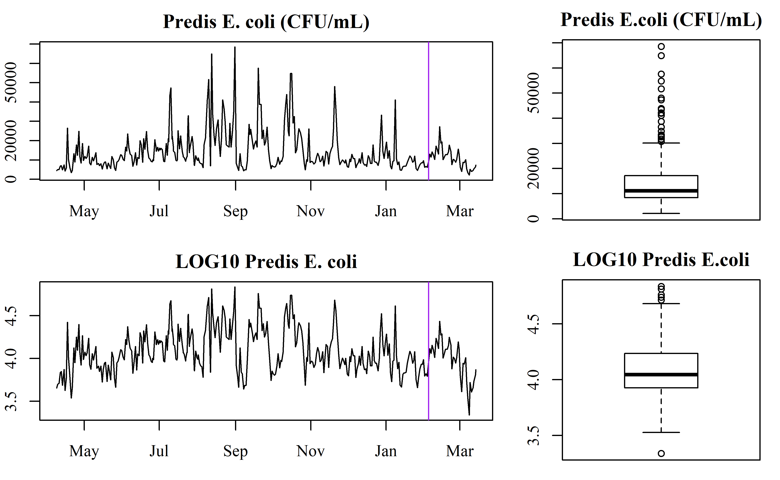

**Table 3.** Variables monitored in the South to predict predisinfection *E. coli* performance. Number of observations is calculated by the number of variables that have a value collected within 24-hours prior to the *E. coli* sample

| **Sorth Variable** | **Collection Method** | **Number of Observations** |
| --- | --- | --- |
| RWH South, Pri Pump Station, Pri Eff ALK | FC24 | 44 |
| RWH South, Pri Pump Station, Pri Eff BOD | FC24 | 304 |
| RWH South, Pri Pump Station, Pri Eff NH3A | FC24 | 314 |
| RWH South, Pri Pump Station, Pri Eff NO5 | FC24 | 128 |
| RWH South, Pri Pump Station, Pri Eff OP | FC24 | 40 |
| RWH South, Pri Pump Station, Pri Eff PW | FC24 | 131 |
| RWH South, Pri Pump Station, Pri Eff TIN | FC24 | 119 |
| RWH South, Pri Pump Station, Pri Eff TKNH | FC24 | 129 |
| RWH South, Pri Pump Station, Pri Eff TN | FC24 | 118 |
| RWH South, Pri Pump Station, Pri Eff TSS | FC24 | 312 |
| RWH South, Disinfection, Eff ALK | FC24 | 141 |
| RWH South, Disinfection, Eff BOD | FC24 | 175 |
| RWH South, Disinfection, Eff NH3A | FC24 | 323 |
| RWH South, Disinfection, Eff NO5 | FC24 | 134 |
| RWH South, Disinfection, Eff OP | FC24 | 39 |
| RWH South, Disinfection, Eff PW | FC24 | 133 |
| RWH South, Disinfection, Eff TIN | FC24 | 127 |
| RWH South, Disinfection, Eff TKNH | FC24 | 134 |
| RWH South, Disinfection, Eff TN | FC24 | 127 |
| RWH South, Disinfection, Eff TSS | FC24 | 180 |
| AB NO 2 ZONE 5 DO CTRL AC S123A | Online | 328 |
| AB NO 2 ZONE 6 DO CTRL AC S123B | Online | 328 |
| AB NO 2 ZONE 7 DO CTRL AC S123C | Online | 328 |
| AB NO 2 ZONE 8 DO CTRL AC S123D | Online | 328 |
| AB NO 6 ZONE 5 DO CTRL AC S163A | Online | 328 |
| AB NO 6 ZONE 6 DO CTRL AC S163B | Online | 328 |
| AB NO 6 ZONE 7 DO CTRL AC S163C | Online | 328 |
| AB NO 6 ZONE 8 DO CTRL AC S163D | Online | 328 |
| AI S568A DMX1 NH3 Analyzer | Online | 328 |
| AI S568D DMX2 NO3 Analyzer | Online | 328 |
| AI S578A DMX1 NH3 Analyzer | Online | 328 |
| AI S578D DMX2 NO3 Analyzer | Online | 328 |
| ASRT ASRT S | Online | 327 |
| CBOD | FC24 | 167 |
| COD | FC24 | 78 |
| ECIDX | Grab | 328 |
| FC T621 | Online | 328 |
| NH3A | Grab | 0 |
| NO5 | Grab | 0 |
| OP | Grab | 0 |
| PAA South Plant Flow | Online | 328 |
| S CMPLX SEC EFF FLOW FI F4 | Online | 328 |
| SSEC AB 1 IN SERVICE HC S110A | Online | 328 |
| SSEC AB 2 IN SERVICE HC S120A | Online | 328 |
| SSEC AB 2 NO3 AI S122D | Online | 328 |
| SSEC AB 2 ZONE 8 TSS AI S125C | Online | 328 |
| SSEC AB 3 IN SERVICE HC S130A | Online | 328 |
| SSEC AB 4 IN SERVICE HC S140A | Online | 328 |
| SSEC AB 5 IN SERVICE HC S150A | Online | 328 |
| SSEC AB 6 IN SERVICE HC S160A | Online | 328 |
| SSEC AB 6 ZONE 8 TSS AI S165C | Online | 328 |
| SSEC AB6 Z4 NH3 AI S163A 4A | Online | 328 |
| SSEC AB6 Z8 NH3 AI S163D 8A | Online | 328 |
| SSEC Ammonia Control PV | Online | 328 |
| SSEC CaRRB 2 SWAS TSS ANALYZER AI S75C | Online | 328 |
| SSEC CaRRB 2B NH3 AI S77A | Online | 328 |
| SSEC CaRRB 3 SWAS TSS ANALYZER AI S85C | Online | 328 |
| SSEC CaRRB Basin 2B NO3 AI S77A | Online | 328 |
| SSEC PEPS NH3 Analyzer AI S50A | Online | 328 |
| SSEC PEPS TSS Analyzer AI S50C | Online | 328 |
| SSEC RAS To SEC Influent Ratio | Online | 327 |
| SSEC Total CaRRB Flow to ABasins FY S102 | Online | 328 |
| SSEC Total PE Flow to ABasins FY S100 | Online | 328 |
| SSEC Total RAS Flow to ABasins FY S101 | Online | 328 |
| SSEC Total RAS Flow To CarrB FI S391 | Online | 328 |
| TI R3003 | Online | 327 |
| TOC | FC24 | 25 |
| TSS | Grab | 0 |
| TSSM | Grab | 0 |

**Figure 2.** South predisinfection *E. coli* for training (before purple line) and testing (after purple line) period. A log10-transform approximates normally distributed training and testing data.

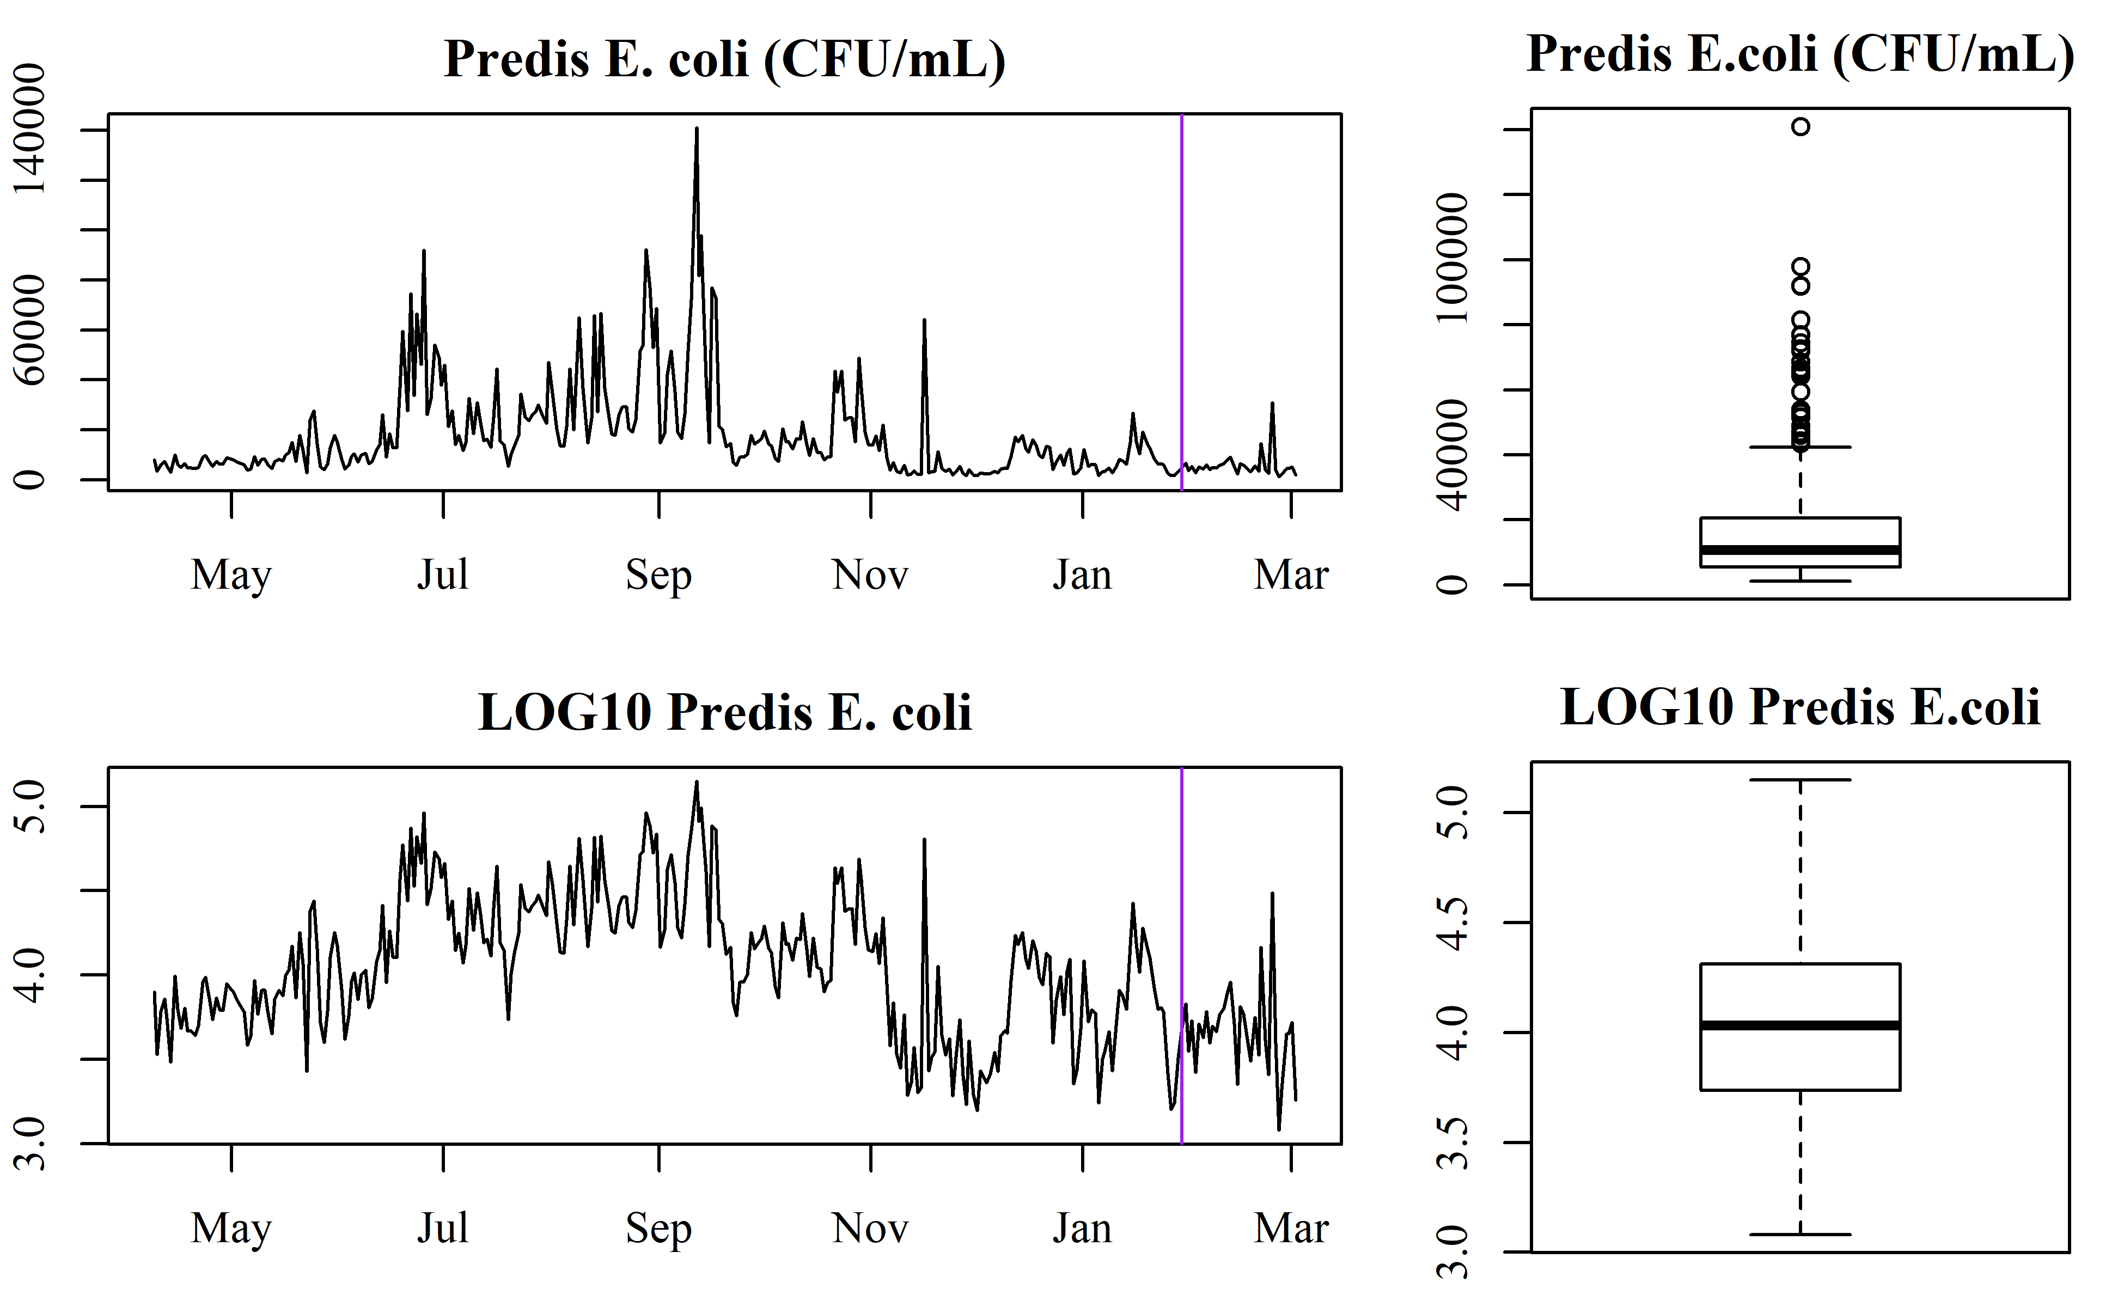

## Recurrent neural networks

* First 90% of data is used to train a recurrent nerual network (RNN)
* Last 10% of data is used to test RNN
* Single layer of *n* long short-term memory (LSTM) nodes, where *n* is the number of variables in the model

# Results

## *E. coli* prediction

### Predisinfection *E. coli*

A few data transformations were used to improve model fit: * average process data to better represent *E. coli* sampling conditions, ranging from 15-minutes to 24-hours * log10-transform of *E. coli* * lag *E. coli* by 2-days While *E. coli* is more highly correlated to the previous *E. coli* observation (1-day), the average time from when a sample is taken to a result is 2-days. Thus, to simulate the use of this model in “real-time” a lag of 2 observations was used.

A common problem in machine learning is *overfitting*. Overfitting occurs when the model-building method continues to adjust model parameters beyond the general trends and instead fits to error within the training dataset. This causes a deceptively high training R2, as the testing root-mean-squared-error (RMSE) is also very high. RMSE can be interpreted as the standard deviation of the unexplained variance and is used to measure testing error here. A good model for real-time prediction minimizes RMSE. Thus, here we examined different number of training periods, from 100-2000. Figure 3 illustrates how R2 is not a good predictor of test RMSE. Currently, *E. coli* is ‘predicted’ by assuming the last known value approximates current conditions. In modeling, this is refered to as *persistence* and is represented as the red, dashed line in Figure 3. Because the model error is less than persistence for 100-750 epochs, and minimized for 100-500 epochs, the ideal number of training epochs being between 100-500.

**Figure 3.** South predisinfection *E. coli* is predicted using a simple RNN, using a various number of epoch (e.g., “re-train” parameter estimations). The red line is the *persistence* RMSE, which is the RMSE calculated from the previously known *E. coli* value. Compared to the model predicted RMSE (black circles), 100-500 training epochs improve upon the current method of estimating *E. coli* (being less than the persistance prediction).

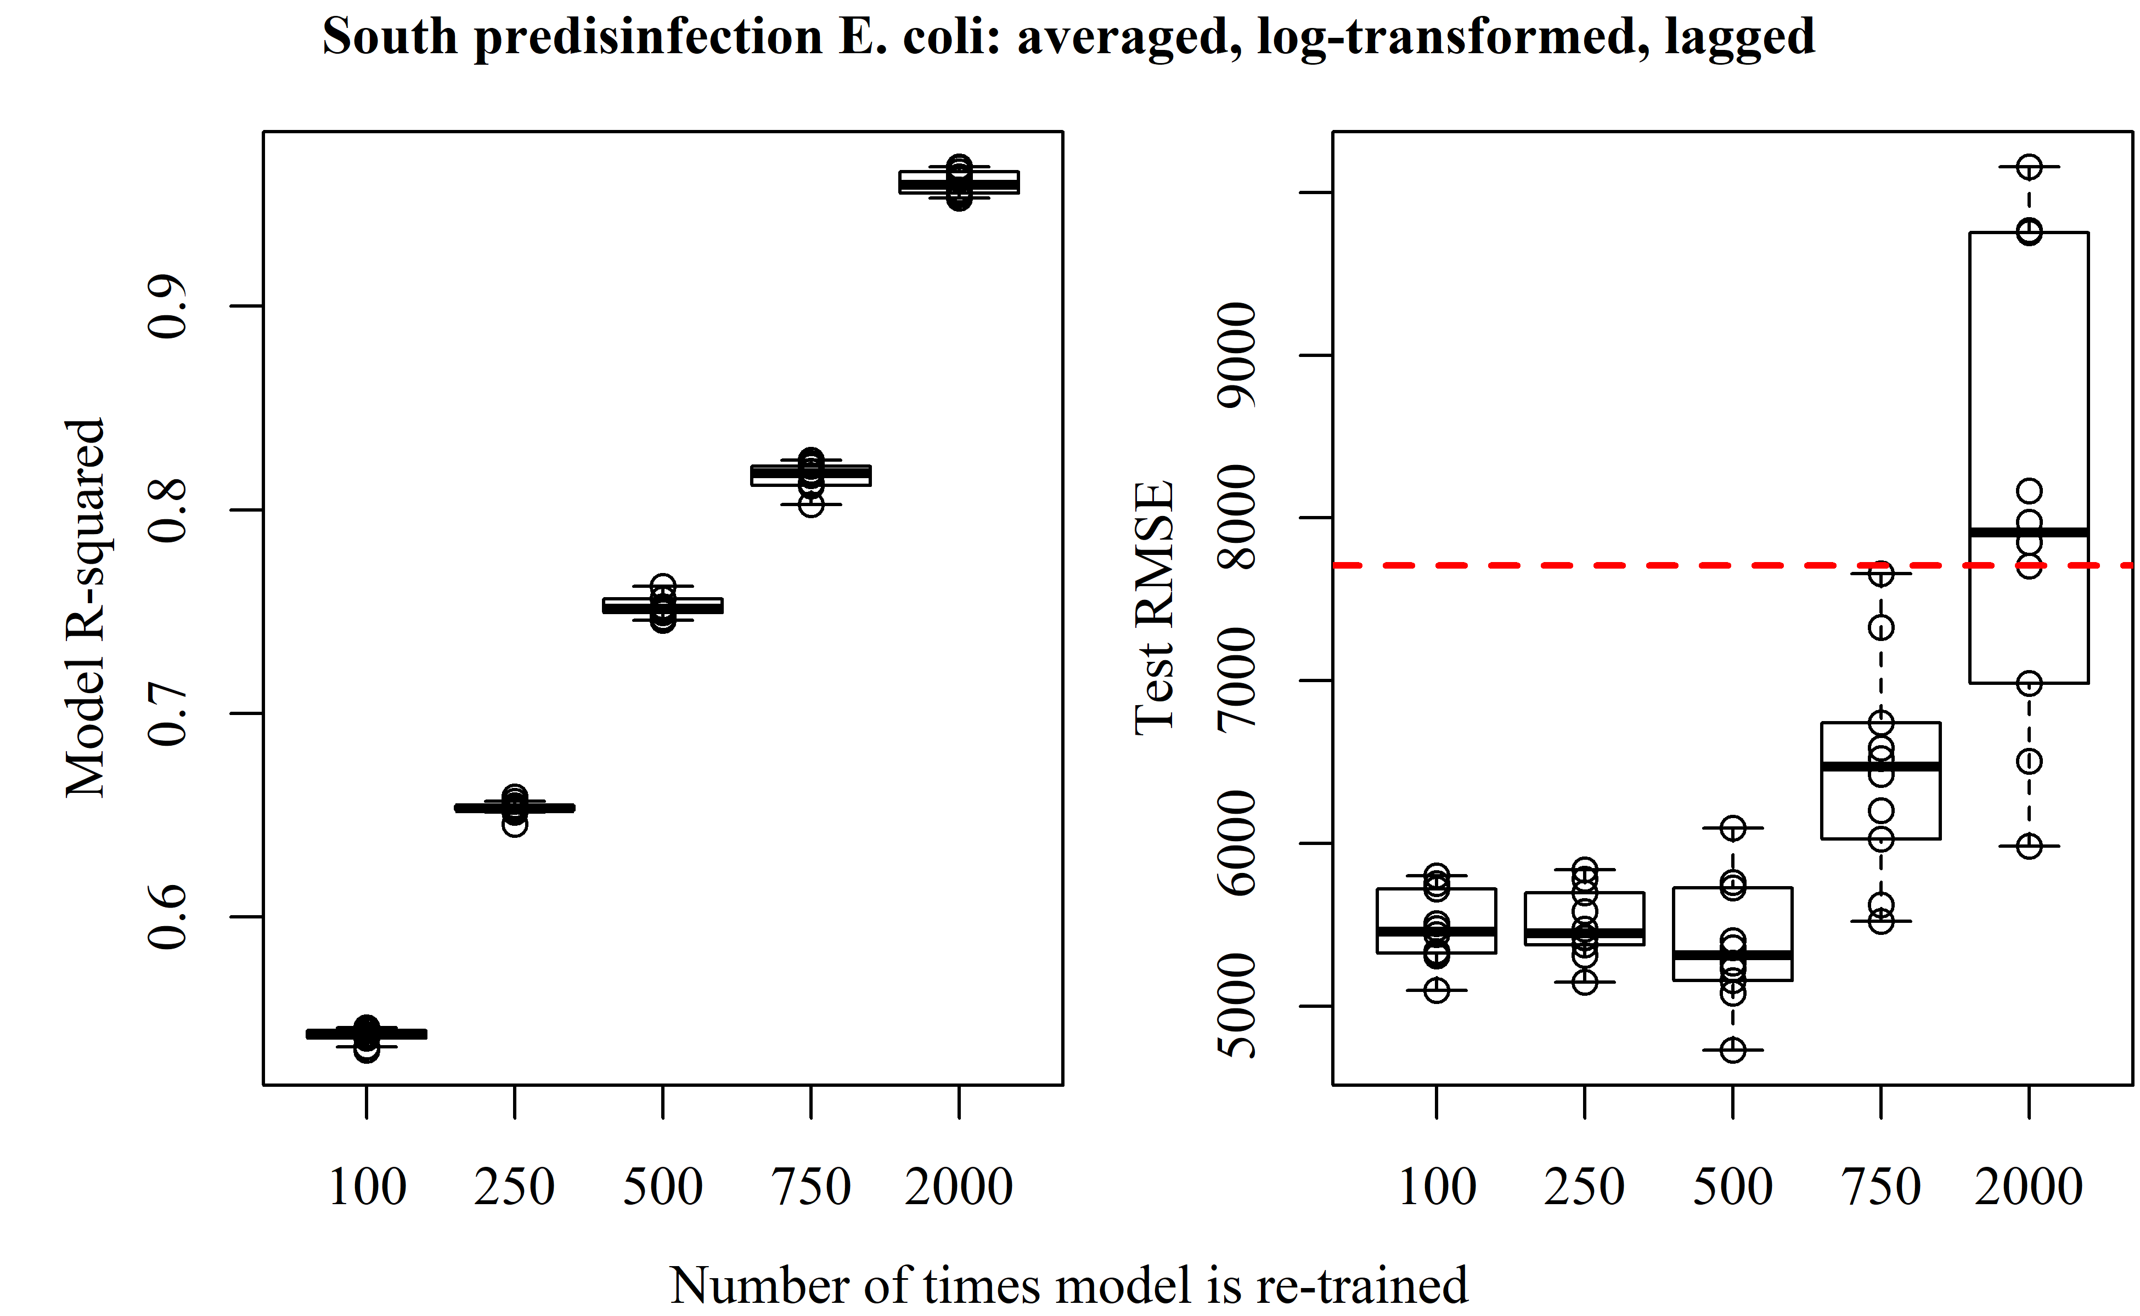

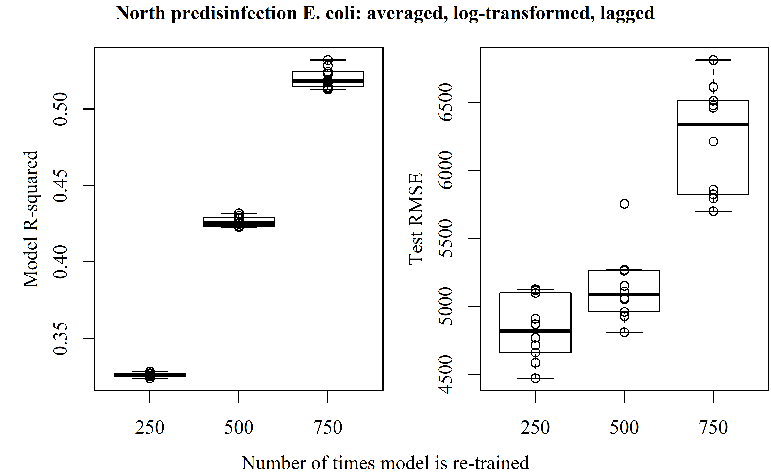

In Figure 4, the best performing model predictions (lowest test RMSE) used are plotted alongside the actual *E. coli* for the entire testing period. For the majority of the testing period, the errors are relatively low, exept for an event on February 25, 2020.

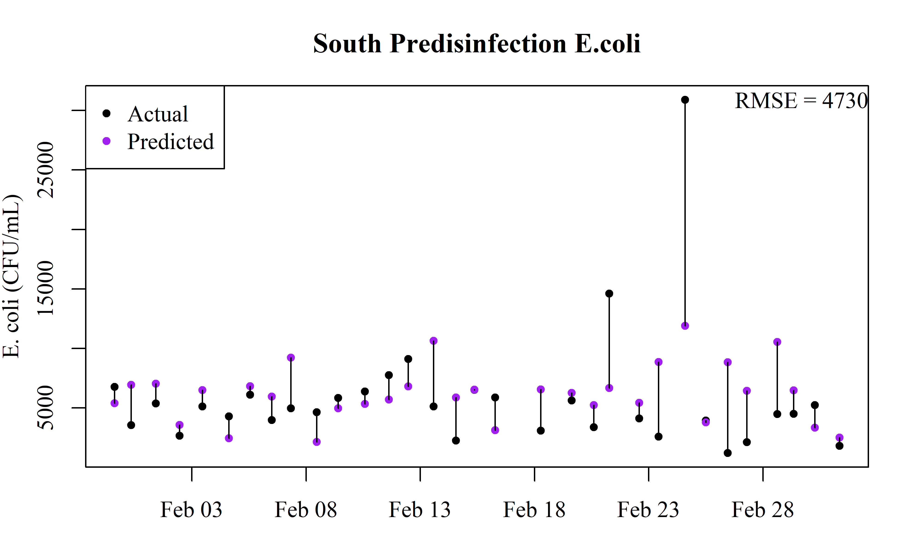

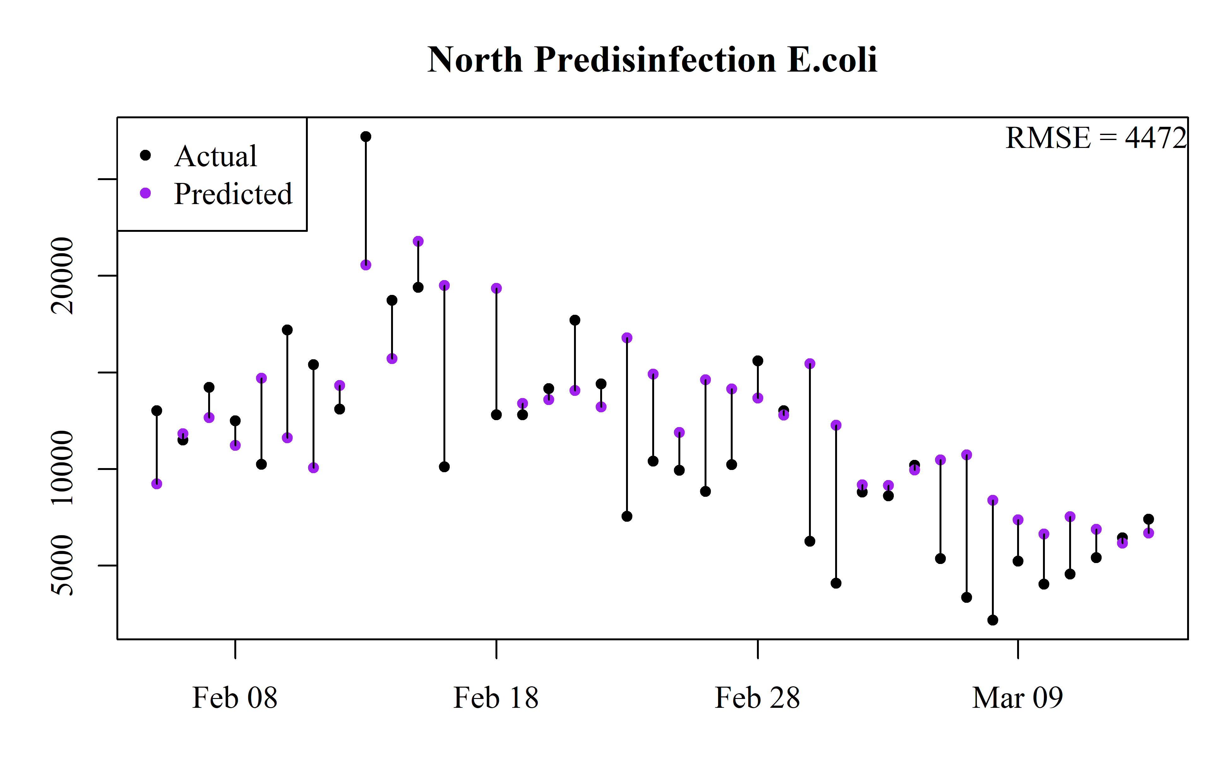

Lin, Chuang-Hung, Ruey-Fang Yu, Wen-Po Cheng, and Chun-Ru Liu. 2012. “Monitoring and Control of UV and UV-TiO2 Disinfections for Municipal Wastewater Reclamation Using Artificial Neural Networks.” *Journal of Hazardous Materials* 209-210 (March): 348–54. <https://doi.org/10.1016/j.jhazmat.2012.01.029>.